ONCOLOGY DRUG DESIGN - VOLUME IV
FLT3-ITD: Target Dossier, Design Criteria and Programme Architecture
A worked target-specific volume. Every quantitative statement is computed from retrieved bioactivity, cohort and structural data, with the provenance and the limits stated alongside.
LESION QUANTITATION · CONFORMATIONAL SELECTIVITY · RESISTANCE ARITHMETIC · TARGET COVERAGE · COMBINATION STRATEGY · SCREENING CASCADE · RISK REGISTER · INTERFACE DECOMPOSITION · FORCE-FIELD ENERGETICS · PROSPECTIVE CANDIDATES
WHAT THIS VOLUME IS, AND HOW IT WAS BUILT
Volumes I to III supply general and oncology-wide mathematics. This volume applies that machinery to one target. It is written for a programme that has to make decisions - which chemotype, which panel, which gate, which combination - and every criterion is therefore tied to a measurement rather than to a convention.
Nothing here is recalled. The inhibitor pharmacology is computed from ChEMBL target CHEMBL1974 (632 activity records for the named agents, 433 retained after filtering to exact-relation nanomolar values with no validity flag). The genomic landscape is computed from public cBioPortal cohorts. The structural analysis is computed from coordinates retrieved from the PDB. Every reference was resolved programmatically and each identifier reverse-validated.
Sec. | Domain | The decision it informs
XXIX | Lesion structure and quantitation | How to measure the ITD, and why it cannot be read off a standard mutation call
XXX | Conformational selectivity and resistance | Which chemotype class to pursue, and which mutants must be in the panel
XXXI | Potency to target coverage | Whether a potency number predicts coverage in a patient
XXXII | Combination and resistance suppression | Which partner, at which exposure, against which escape route
XXXIII | Screening cascade and gates | What to run, in what order, and what kills a compound
XXXIV | Programme risk register | The real failure modes, and the experiment that tests each
XXXV | Interface decomposition | What a back-pocket-free chemotype gives up, and where to recover it
XXXVI | Force-field energetics | Whether that surface delivers energy, and what a contact score cannot predict
XXXVII | Prospective candidates | Molecules that satisfy the criterion, and the receptor in which it must be tested

DATA PROVENANCE AND ITS LIMITS Three limits govern how the numbers here should be used. First, ChEMBL aggregates heterogeneous assay conditions, so potency medians characterise class behaviour and must not be quoted as head-to-head comparisons; the record count is given alongside every value. Second, the broad landscape query returned 1000 of 3807 records above the potency threshold, so it is a sample rather than an exhaustive census. Third, standard short-read cohorts largely do not resolve FLT3-ITD - only one of the six cohorts examined calls ITD events at all, and even there the annotation collapses (Section 29.2). Where a quantity could not be derived safely, this volume says so instead of estimating it.

XXIX. FLT3-ITD: LESION STRUCTURE AND ITS QUANTITATION
FLT3 internal tandem duplication is an in-frame duplication in the juxtamembrane domain that removes the domain's autoinhibitory function, giving a constitutively active receptor that signals through STAT5, and secondarily through MAPK and PI3K. Two properties make it unlike a point-mutation target: the lesion is a duplication of variable length and position rather than a single substitution, and it is present at a variable allele burden. Both are measured quantities that enter design and stratification, and neither is recoverable from a standard short-read mutation call.
29.1 Allelic Ratio
AR = area(ITD peak) / area(wild-type peak)
ITD Allelic Ratio (fragment analysis)

VAF = ITD reads / (ITD reads + WT reads)
AR = VAF / (1 - VAF) and VAF = AR / (1 + AR)
Conversion Between AR and VAF

AR >= 0.5 <-> VAF >= 0.333 (the common high-burden threshold)
Threshold Equivalence

WHY AR AND VAF MUST NOT BE USED INTERCHANGEABLY AR is a ratio of mutant to wild type and is unbounded above; VAF is a fraction of total and is bounded by 1. A cohort reported in AR and a cohort reported in VAF cannot be pooled without the conversion above. Report which quantity was measured, the platform that measured it, and the threshold applied - the threshold is a stratification convention, not a biological constant, and its use has changed as risk classifications have been revised.

29.2 ITD Length and Insertion Site
L_ITD = length of the duplicated segment in base pairs; L_aa = L_ITD / 3
ITD Length

In-frame requirement: L_ITD mod 3 = 0
Reading-Frame Constraint

Insertion site is conventionally described relative to the juxtamembrane domain and the first tyrosine kinase subdomain. A duplication confined to the juxtamembrane region and one that extends into the beta1-sheet of the kinase domain are not equivalent lesions: the latter changes residues that form part of the ATP site itself, and has been associated with worse outcome and with reduced inhibitor sensitivity. For a structure-based programme this matters directly - it is the difference between an unchanged drug site and an altered one.
MEASUREMENT REQUIREMENT, NOT AN ASSUMPTION The cohort analysis in this volume shows why this must be measured rather than mined. In the BeatAML cohort, 210 FLT3 in-frame insertion events carry 61 distinct annotation strings, but a single string accounts for 137 of them. Real ITDs are near-unique to each patient, so that dominant string is a collapsed representation rather than 137 identical lesions. Taking insertion site from these calls is unsafe: the apparent fraction inserting at or beyond residue 610 falls from 0.68 to 0.09 once that one annotation is set aside. Use ITD-aware assays - fragment analysis for burden, and long-read or assembly-based sequencing for length and position.

29.3 Lesion Prevalence and Genomic Context
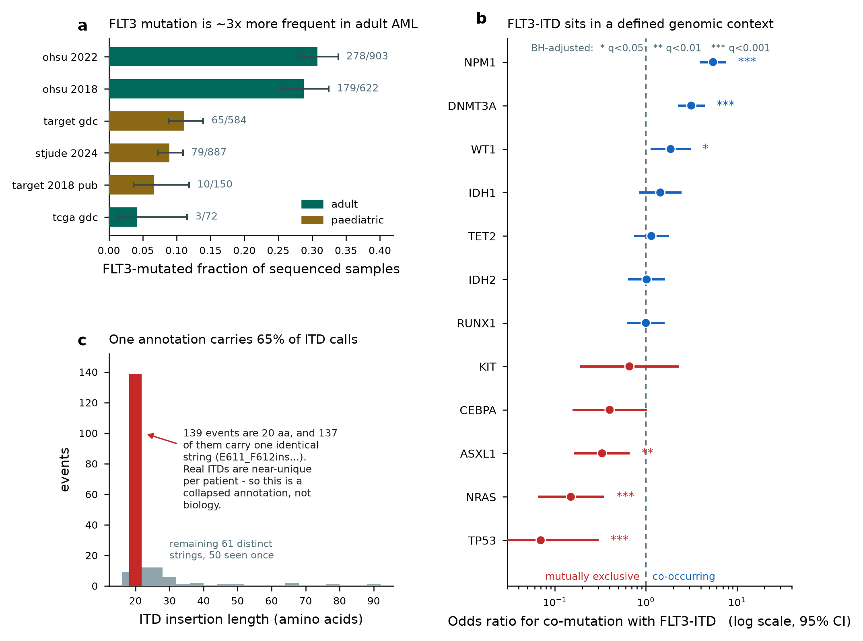
Figure. FLT3 alteration landscape computed from public cBioPortal cohorts. (a) FLT3-mutated fraction with Wilson 95% intervals; adult cohorts run about three-fold higher than paediatric. (b) Odds ratios for co-mutation with FLT3-ITD in BeatAML (n=903), Fisher exact with Benjamini-Hochberg adjustment. (c) The ITD annotation-collapse artefact described in 29.2.

Cohort | Group | Mutated | Sequenced | Freq. | 95% lo | 95% hi
ohsu 2022 | adult | 278 | 903 | 0.308 | 0.279 | 0.339
ohsu 2018 | adult | 179 | 622 | 0.288 | 0.254 | 0.325
target gdc | paediatric | 65 | 584 | 0.111 | 0.088 | 0.139
stjude 2024 | paediatric | 79 | 887 | 0.089 | 0.072 | 0.11
target 2018 pub | paediatric | 10 | 150 | 0.067 | 0.037 | 0.118
tcga gdc | adult | 3 | 72 | 0.042 | 0.014 | 0.115

Within the one cohort that resolves ITD events, FLT3-ITD is present in 209 of 903 samples (23.1%) and activation-loop mutation in 59 (6.5%), with 11 samples carrying both. The co-mutation structure is strongly non-random, and it is the part of the landscape that should shape a development plan.
Gene | n mutated | co-mut with ITD | % of ITD+ | OR | CI lo | CI hi | q (BH)
NPM1 | 233 | 112 | 53.6 | 5.47 | 3.91 | 7.65 | 2.1e-22
DNMT3A | 197 | 81 | 38.8 | 3.15 | 2.24 | 4.44 | 7.6e-10
WT1 | 72 | 25 | 12.0 | 1.87 | 1.12 | 3.12 | 3.9e-02
IDH1 | 71 | 21 | 10.0 | 1.44 | 0.84 | 2.46 | 2.8e-01
TET2 | 118 | 30 | 14.4 | 1.15 | 0.74 | 1.8 | 7.4e-01
IDH2 | 111 | 26 | 12.4 | 1.02 | 0.64 | 1.63 | 9.9e-01
RUNX1 | 108 | 25 | 12.0 | 1.0 | 0.62 | 1.61 | 1.0e+00
KIT | 18 | 3 | 1.4 | 0.66 | 0.19 | 2.3 | 9.3e-01
CEBPA | 45 | 5 | 2.4 | 0.4 | 0.16 | 1.03 | 1.2e-01
ASXL1 | 93 | 9 | 4.3 | 0.33 | 0.16 | 0.66 | 1.6e-03
NRAS | 119 | 6 | 2.9 | 0.15 | 0.07 | 0.35 | 8.6e-08
TP53 | 82 | 2 | 1.0 | 0.07 | 0.02 | 0.3 | 2.2e-07

THREE CONSEQUENCES FOR A DEVELOPMENT PLAN First, NPM1 co-mutation (OR 5.47, q = 2e-22) and DNMT3A (OR 3.15, q = 8e-10) define the dominant context - the three-way NPM1/DNMT3A/FLT3-ITD genotype is 27.8% of ITD-positive cases here, so a trial population is largely this genotype whether or not it is selected for. Second, TP53 (OR 0.07) and NRAS (OR 0.15) are close to mutually exclusive with ITD at diagnosis; their near-absence at baseline is precisely why RAS-pathway activation is available as an escape route under treatment, and it should be measured at progression rather than assumed absent. Third, KIT co-mutation is rare (OR 0.66, not significant), so KIT inhibition buys no efficacy here and contributes only myelosuppression - see 31.4.

XXX. CONFORMATIONAL SELECTIVITY AND THE RESISTANCE ARITHMETIC
The central quantitative fact of FLT3 drug design is that the inhibitor's binding mode determines which resistance mutations defeat it. This section defines the metrics, then demonstrates them on the clinically precedented agents using curated bioactivity data and solved co-complex structures.
30.1 Binding-Mode Classification
Type I : binds the ACTIVE (DFG-in) conformation; occupies the ATP site only
Type II : binds the INACTIVE (DFG-out) conformation; extends past the
gatekeeper into the back (allosteric) pocket
Inhibitor Class Definition

Back-pocket occupancy N_bp = number of contacted residues among
{alphaC-Glu661, Met664, Met665, Ile674, His809(HRD), Ala833}
at a heavy-atom cut-off of 4.5 A
Structural Class Discriminator

N_bp is a directly measurable classifier and it separates the classes cleanly on real structures. Computed from the FLT3 co-complexes, quizartinib contacts 5 of the 5 catalytic-lysine / alphaC back-pocket residues, whereas gilteritinib contacts none of them and does not touch the F691 gatekeeper at all.
ATP-site region | quizartinib (II) | gilteritinib (I) | FF-10101 (cov.)
glycine-rich loop | 2 | 3 | 3
gatekeeper | 1 | 0 | 1
hinge / solvent front | 6 | 7 | 7
catalytic K / alphaC back pocket | 5 | 0 | 1
HRD / catalytic | 3 | 1 | 2
DFG + activation loop | 5 | 3 | 3

A METRIC THAT DID NOT WORK, REPORTED AS SUCH The conventional DFG-in/out discriminator - displacement of the DFG phenylalanine, measured here as the F830 CZ distance to the beta3-lysine K644 CA - did NOT separate these structures: 8.36 A in apo 1RJB against 10.10, 10.88 and 10.74 A in the three co-complexes. Whatever conformational differences exist between these particular crystal forms, this metric does not capture them, and the class assignment above rests on back-pocket occupancy instead. Do not carry the DFG-distance criterion into an FLT3 programme on the assumption that it will discriminate.

PDB | Ligand | F830-K644 (A) | F830-E661 (A) | K644-E661 salt bridge (A) | N_bp | Touches F691
1RJB | (apo) | 8.36 | 15.12 | 2.59 | nan | -
4XUF | P30 | 10.1 | 14.55 | 2.61 | 6.0 | True
6JQR | C6F | 10.88 | 11.33 | 3.48 | 0.0 | False
5X02 | F6M | 10.74 | 15.5 | 2.73 | 0.0 | True

30.2 Resistance Fold-Shift
FS_mut = IC50(FLT3-ITD + mut) / IC50(FLT3-ITD)
Mutant Fold-Shift

Design criterion: FS < 5 across the full mutant panel,
with absolute mutant IC50 still below the cellular target concentration
Panel Criterion

Fold-shift must be reported with its panel and its n. A compound with FS = 3 measured against one mutant in one assay has not been characterised. The panel below is the minimum: ITD alone, ITD plus each common activation-loop substitution, and ITD plus the gatekeeper substitution.
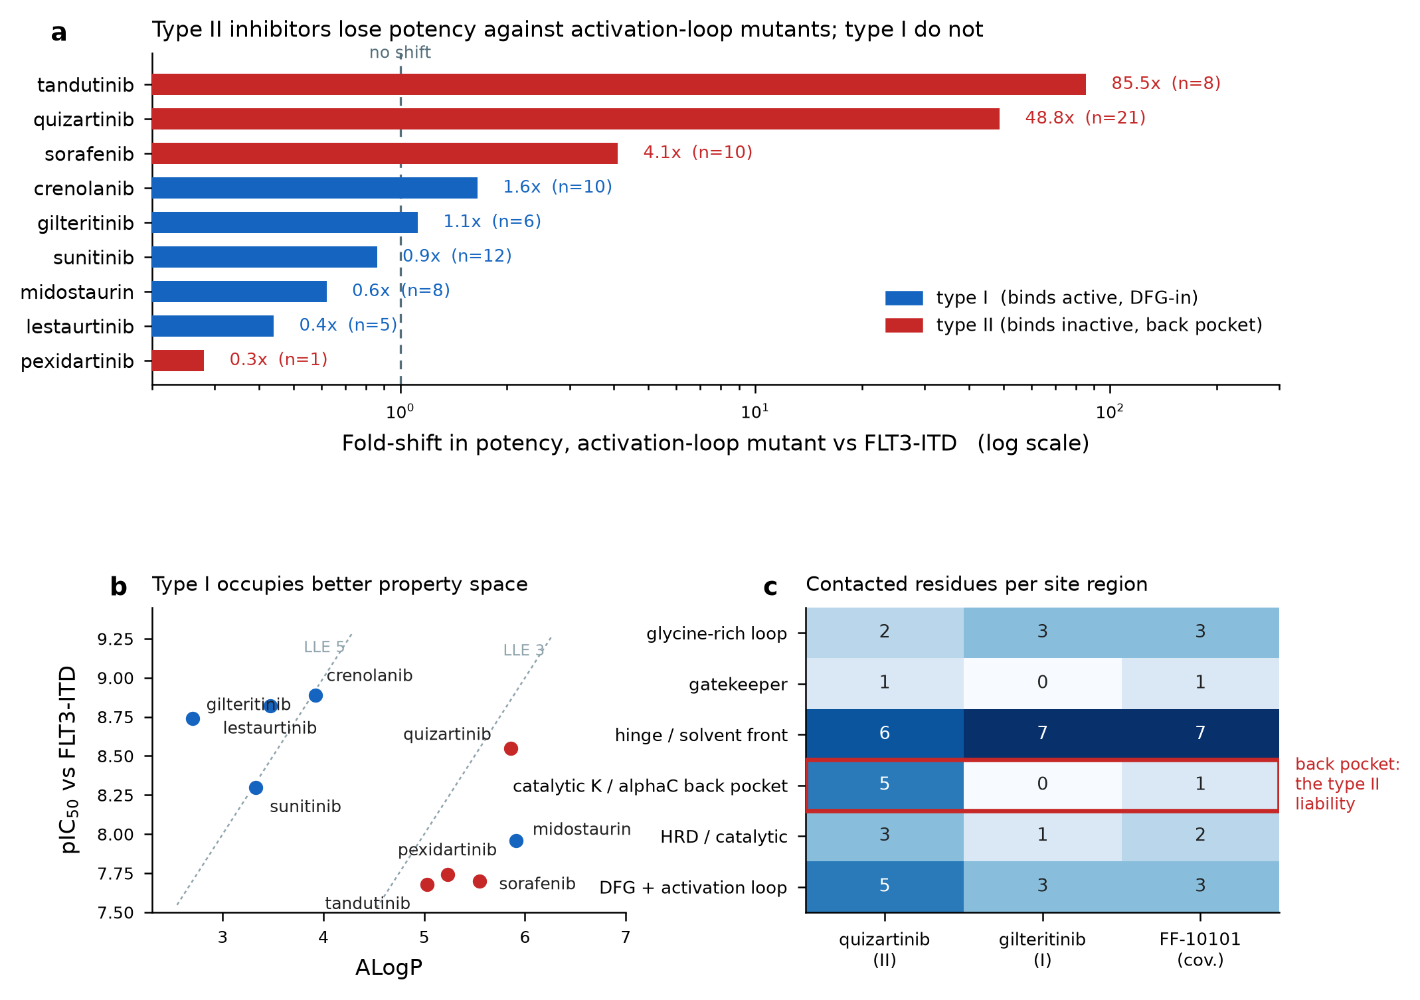
Figure. FLT3 inhibitor landscape computed from ChEMBL target CHEMBL1974. (a) Activation-loop fold-shift per agent with the number of underlying records; type II agents lose potency, type I do not. (b) Potency against FLT3-ITD versus lipophilicity with lipophilic-ligand-efficiency reference lines. (c) Contacted residues per ATP-site region from the co-complex structures, with the back-pocket row highlighted.

Agent | Class | ITD (nM) | Act.-loop (nM) | FS | n records | FS F691L
lestaurtinib | I | 1.5 | 0.66 | 0.44 | 5 | -
midostaurin | I | 11.0 | 6.8 | 0.62 | 8 | -
sunitinib | I | 5.0 | 4.3 | 0.86 | 12 | -
gilteritinib | I | 1.8 | 2.01 | 1.12 | 6 | 5.6
crenolanib | I | 1.3 | 2.15 | 1.65 | 10 | 16.9
pexidartinib | II | 18.0 | 5.0 | 0.28 | 1 | -
sorafenib | II | 20.0 | 82.0 | 4.1 | 10 | 43.0
quizartinib | II | 2.8 | 137.0 | 48.84 | 21 | 121.2
tandutinib | II | 21.05 | 1800.0 | 85.51 | 8 | -
ponatinib | II | - | 438.0 | - | 1 | -

THE RESULT, AND ITS LIMITS Median activation-loop fold-shift is 0.86 for the five type I agents and 26.5 for the four type II agents - a roughly 30-fold difference in class behaviour, and the mechanistic reason is the back-pocket dependence quantified in 30.1. The honest statistical statement is that a Mann-Whitney test on this 9-compound set gives p = 0.143: the effect size is large but the set is far too small for significance, and the type II group includes one agent (pexidartinib) whose value rests on a single record. Treat this as a mechanistic consistency check against known pharmacology, not as an independent statistical finding. Potency values are medians over heterogeneous ChEMBL assay conditions, so they are indicative of class behaviour rather than definitive head-to-head comparisons.

30.3 Gatekeeper and Compound Escape
F691L is the FLT3 gatekeeper substitution, positionally analogous to
the gatekeeper substitutions that defeat inhibitors of other kinases
Gatekeeper Escape

The gatekeeper shifts potency for both classes in the retrieved data, but by very different margins: 5.6-fold for gilteritinib and 16.9-fold for crenolanib against 121-fold for quizartinib and 43-fold for sorafenib. Note that gilteritinib makes no contact with F691 in 6JQR, so its residual shift is an indirect packing effect rather than a lost direct contact - which is the structural argument for why a type I chemotype has more room to absorb this substitution. The F691L numbers rest on one to three records each and are the weakest data in this volume.
Compound resistance: FS_total for ITD + AL + gatekeeper is NOT the product
of the single-mutant fold-shifts; it must be measured
No Multiplicative Assumption

30.4 Selection Pressure and the Escape Budget
P(escape clone present) = 1 - exp(-u x N_cells)
Pre-Existing Resistance (Vol. III, 22.1)

Suppression condition: the inhibitor must hold every accessible
single-mutant escape route below its cellular IC90 at C_trough
Design Target

WHY SINGLE-AGENT ON-TARGET COVERAGE IS THE WHOLE GAME Leukaemic burden at diagnosis is large enough that escape substitutions are available before the first dose. A compound that covers the activation loop and the gatekeeper removes the two dominant on-target routes at once, which is why breadth across the mutant panel is worth more than incremental potency against ITD alone. Once on-target routes are closed, escape moves off-target - to RAS-pathway activation, which the co-mutation data in 29.3 show is largely absent at diagnosis and therefore available later.

XXXI. FROM BIOCHEMICAL POTENCY TO TARGET COVERAGE IN PATIENTS
FLT3 inhibitors fail the translation step more often than the potency step. Three corrections stand between a biochemical IC50 and a defensible prediction of target coverage, and this chemotype is unusually exposed to all three.
31.1 Unbound Potency
C_u = f_u x C_total
Unbound Concentration

IC50_unbound-equivalent = IC50(assay) x (f_u,assay / f_u,plasma)
Protein-Binding Correction

Occupancy at trough: RO = C_u,trough / (C_u,trough + K_d)
Unbound Target Occupancy

THE CHEMOTYPE-SPECIFIC WARNING Section XXX shows type II FLT3 agents cluster at high lipophilicity - mean ALogP 5.23 against 3.87 for the type I agents in this set - and high lipophilicity predicts high plasma protein binding. A potency measured in a low-protein biochemical buffer can therefore overstate achievable coverage by one to two orders of magnitude. Measure f_u in the relevant matrix, report every potency as unbound-equivalent, and never compare a buffer IC50 with a plasma-containing cellular IC50.

31.2 Plasma Inhibitory Activity - the FLT3-Specific Endpoint
The plasma inhibitory activity assay is the pharmacodynamic measurement that FLT3 development is built on and that has no close analogue in other target classes. Patient plasma taken at a chosen timepoint is applied to a FLT3-ITD-dependent reporter cell line, and phosphorylated FLT3 is quantified. It integrates exposure, protein binding and active metabolites into a single number, which is exactly what the corrections in 31.1 are trying to approximate.
PIA(%) = 100 x [1 - (pFLT3 signal in patient plasma at time t /
pFLT3 signal in baseline or control plasma)]
Plasma Inhibitory Activity

Programme criterion: sustained deep pFLT3 inhibition at C_trough,
measured in plasma rather than inferred from a biochemical IC50
PD Criterion

REPORTING RULE The specific inhibition threshold associated with clinical response should be taken from the primary PIA literature for the agent class and cited, not carried over from another programme. What is transferable is the requirement itself: define the threshold, the timepoint, the reporter line and the reference plasma before the trial, and power the PD sampling to detect failure at trough rather than at peak.

31.3 Proximal and Distal Pharmacodynamics
Proximal: pFLT3, and pSTAT5 as the principal downstream node
Signalling Readouts

Distal: blast differentiation, peripheral and marrow blast clearance,
ITD-specific measurable residual disease (Vol. III, XXV)
Response Readouts

MRD by ITD-specific assay: report the assay's own limit of detection;
an ITD-specific method must be designed per patient lesion
MRD Caveat

31.4 Selectivity - Where the Toxicity Comes From
SI_KIT = IC50(KIT) / IC50(FLT3-ITD) target: SI_KIT > 100
KIT Selectivity Index

KIT inhibition is the principal driver of on-target myelosuppression for this class, and the co-mutation data give no efficacy argument to offset it: KIT is mutated in only 2.0% of the adult cohort and is not enriched in ITD-positive cases. KIT selectivity is therefore a pure safety parameter, and it belongs in the primary screening cascade rather than in a late off-target panel.
Broad panel: report the fraction of a kinase panel inhibited >50%
at a fixed multiple of the FLT3 IC50, plus selectivity entropy (Vol. II, 18.4)
Panel Selectivity

CLINICAL FRAMING Differentiation syndrome and QT prolongation are recognised class effects for FLT3 inhibitors and are managed clinically through monitoring, supportive care and dose modification. The design-side consequences are that hERG and QT liability belong in the cascade early (see XXXII), and that a differentiation-driven early rise in blast counts must be distinguished in protocol from progression. Neither is a dosing instruction: management for any patient is a decision for the treating clinician with the full clinical picture.

XXXII. COMBINATION STRATEGY AND RESISTANCE SUPPRESSION
No single-agent FLT3 inhibitor has proved curative, and the reason is structural rather than pharmacological: FLT3-ITD is a proliferative lesion sitting on top of a founding clone defined by other mutations. Inhibiting FLT3 removes the proliferative advantage without eliminating the clone that carries it. Combination design therefore has to target the survival dependency and the founding lesion, not just add a second FLT3 inhibitor.
32.1 Apoptotic-Priming Combinations
FLT3-ITD signalling raises MCL1 and phosphorylates BAD via STAT5/PIM;
FLT3 inhibition lowers MCL1 and shifts dependence toward BCL2
Mechanistic Rationale

Combination criterion: measure synergy against a NAMED null model
(Bliss, Loewe/CI or ZIP - Vol. II, XIV) across a full dose matrix
Synergy Requirement

Report the concentration ratio at which synergy occurs AND whether
both agents reach those unbound concentrations at tolerated doses
Translatability Test

THE TEST MOST SYNERGY CLAIMS FAIL A synergy score computed at concentrations neither agent reaches in plasma is not evidence of clinical benefit. For this class the binding correction in 31.1 makes that failure especially easy: an in vitro matrix run in low-protein medium can show strong synergy at unbound concentrations an order of magnitude above what the tolerated human dose delivers. Compute the matrix, then check both axes against achievable unbound exposure before claiming anything.

32.2 Targeting the Founding Clone
The co-mutation analysis in 29.3 is a direct argument about combination partners. The dominant context is NPM1 and DNMT3A co-mutation - these are founding lesions present in the clone that persists through FLT3 inhibition. Hypomethylating agents and menin inhibitors act on that biology rather than on FLT3, which is what makes them mechanistically non-redundant partners rather than additive cytotoxicity.
Partner selection principle: a partner should address a lesion in the
FOUNDING clone, or a survival dependency, not a parallel proliferative input
Non-Redundancy

32.3 Escape Routes and What Closes Them
Escape route | What the data here say | What closes it
Activation-loop substitution (D835/I836) | Present in 6.5% of the adult cohort at diagnosis and in 11 samples together with ITD; defeats type II agents (median FS 26.5) but not type I (0.86). | A type I chemotype, or a chemotype whose N_bp = 0 by the 30.1 criterion.
Gatekeeper substitution (F691L) | Shifts every agent measured, from 5.6-fold (gilteritinib) to 121-fold (quizartinib). Weakest dataset in this volume: 1-3 records per agent. | Chemotype with no direct F691 contact and slack in the hinge region; must be measured, not predicted.
RAS-pathway activation | NRAS is near-mutually-exclusive with ITD at diagnosis (OR 0.15, q=9e-8), so this route is largely unoccupied at baseline and available under treatment. | A combination partner acting downstream or on the founding clone; serial RAS-pathway genotyping at progression.
Loss of ITD dependence / lineage switch | Not assessable from these cohorts - requires paired diagnosis-relapse sampling. | Paired sampling built into the trial design from the outset, not retrofitted.
Inadequate target coverage (pseudo-resistance) | Predicted by the binding correction in 31.1; high-ALogP type II agents are most exposed. | PIA-based confirmation of trough coverage before concluding that biology, rather than exposure, caused the failure.

THE MOST COMMON DIAGNOSTIC ERROR Before attributing a clinical failure to a resistance mutation, confirm that the drug was covering the target at trough. Insufficient unbound exposure and true on-target resistance look identical in an efficacy readout and have opposite remedies - one needs a dose or formulation change, the other needs a different molecule. The PIA assay in 31.2 exists to separate them.

XXXIII. SCREENING CASCADE AND GO / NO-GO CRITERIA
A cascade is only useful if each stage has a numeric gate decided before the data arrive. The criteria below are working criteria for an FLT3-ITD programme, set from the class behaviour quantified in this volume. They are starting points to be calibrated against your own assays, not regulatory requirements.
33.1 Staged Cascade
Stage | Assay | Primary readout | Go criterion | Kill criterion
1. Primary biochemical | FLT3-ITD kinase-domain activity, ATP at K_m | IC50 vs FLT3-ITD | IC50 < 10 nM and LE >= 0.30 | IC50 > 100 nM
2. Mutant panel | ITD + D835Y/H/V, I836del, F691L, plus WT FLT3 (33.3) | Fold-shift FS per mutant | FS < 5 for every member | FS > 20 for any activation-loop member
3. Cellular, ITD-dependent | ITD-driven line vs ITD-negative comparator line, in 10% serum | Cell IC50 and the ITD / non-ITD ratio | Cell IC50 < 50 nM and ratio > 20 | Ratio < 5 (general cytotoxic)
4. Proximal PD | pFLT3 and pSTAT5 in the ITD-driven line | pSTAT5 IC50 vs viability IC50 | Within 3-fold of viability IC50 | No pSTAT5 shift at 10x viability IC50
5. Selectivity | KIT biochemical + cellular; broad kinase panel (31.4) | SI_KIT and panel hit fraction | SI_KIT > 100 | SI_KIT < 10
6. Developability | Solubility, permeability, microsomal and hepatocyte stability, f_u, hERG | Unbound-corrected potency; hERG margin | f_u measured; hERG IC50 / free C_max > 30 | hERG margin < 10
7. In vivo PK/PD | Single-dose PK then pSTAT5 / pFLT3 time course in the ITD model | Unbound trough coverage vs cellular IC90 | C_u,trough > cellular IC90 at a tolerated dose | Coverage requires an intolerable dose
8. In vivo efficacy | ITD-driven xenograft or syngeneic model, plus one activation-loop model | TGI (Vol. I, 5.5) and survival | Regression in the ITD model, activity retained in the mutant model | No activity in the mutant model

33.2 Assay Acceptance Criteria
Z' = 1 - 3(sd_pos + sd_neg) / |mean_pos - mean_neg| require Z' >= 0.5
Screening Assay Quality

Replicate agreement: |pIC50_rep1 - pIC50_rep2| <= 0.3 for >= 90% of pairs
Reproducibility Gate

4PL fit acceptance: Hill slope within 0.5-2.0, top and bottom plateaus
defined, and IC50 bracketed by tested concentrations
Curve-Fit Gate

THE CONTROL THAT MAKES THE CASCADE INTERPRETABLE Every cellular stage needs an ITD-independent comparator run in parallel. A compound that kills an ITD-driven line and an ITD-negative line equally is a general cytotoxic, and no amount of biochemical selectivity rescues that. The ratio of the two cellular potencies is the single most informative number in the cascade, and it is cheap to generate.

33.3 Mutant Panel - the Minimum Set
Required panel: ITD alone; ITD + D835Y; ITD + D835H; ITD + D835V;
ITD + I836del; ITD + F691L; and wild-type FLT3 for reference
Mutant Panel

These are the substitutions that actually recur. In the BeatAML cohort the activation-loop events are dominated by D835Y (19 events), D835H (15), I836del (9) and D835V (7); the same ranking appears in the paediatric TARGET cohort with D835Y again first. A panel that omits D835H and I836del is not covering the observed mutational spectrum.
Acceptance: FS < 5 for every panel member AND absolute mutant IC50
below the cellular target concentration
Panel Gate

XXXIV. PROGRAMME RISK REGISTER
The risks below are specific to FLT3-ITD rather than generic drug-development risks, each paired with the mitigation and - more importantly - the experiment that tests whether the mitigation is working. A risk without a discriminating experiment is an opinion.
Risk | Why it is real here | Mitigation | The experiment that tests it
Crowded competitive landscape | Four agents are clinically precedented, two approved as single agents in the relapsed setting. A new agent with equivalent profile has no route to differentiation. | Define differentiation numerically at the outset - mutant-panel breadth, KIT selectivity, or combinability - and hold the programme to it. | Head-to-head mutant-panel and KIT selectivity comparison against the precedented agents, run in your own hands, before candidate selection.
On-target myelosuppression via KIT | KIT is the principal haematological liability; the cohort data give no efficacy offset (2.0% mutated, not ITD-enriched). | Treat SI_KIT > 100 as a primary gate, not a late characterisation. | KIT biochemical and cellular potency at the same stage as FLT3, with colony-forming assays on normal progenitors.
Activation-loop escape | 6.5% of adult cases carry it at diagnosis; it defeats the type II class (median FS 26.5). | Select a chemotype with N_bp = 0 by the 30.1 structural criterion. | The full mutant panel in 33.3, with the ITD-negative control line.
Gatekeeper escape (F691L) | Shifts potency for both classes; the public dataset is thin (1-3 records per agent). | Build F691L into the primary panel rather than treating it as an afterthought. | Direct measurement - the public data are too sparse to predict from.
Pseudo-resistance from poor coverage | High-ALogP type II chemotypes are heavily protein-bound; buffer potency overstates coverage. | Report unbound-equivalent potency throughout; make PIA the PD gate. | PIA at trough in the first-in-human cohorts, before any resistance claim.
Single-agent insufficiency | FLT3-ITD sits on a founding NPM1/DNMT3A clone that FLT3 inhibition does not remove (27.8% of ITD+ cases are the triple genotype). | Plan the combination from the start; do not treat it as a salvage strategy after monotherapy disappoints. | Dose-matrix synergy against a named null model, then the achievable-exposure check in 32.1.
ITD lesion not properly characterised | Standard short-read calls collapse ITD annotations - demonstrated in 29.2. | Specify ITD-aware assays for burden, length and insertion site in the protocol. | Orthogonal confirmation on a sample subset: fragment analysis against long-read or assembly-based sequencing.
Differentiation syndrome and QT liability | Recognised class effects for FLT3 inhibitors. | hERG and QT assessment early in the cascade; protocol language distinguishing differentiation from progression. | hERG patch-clamp and in vivo QT telemetry before candidate selection; prospective adjudication criteria in the protocol.

34.1 What Would Make This Programme Succeed
Reduced to its essentials: pick a type I-like chemotype whose back-pocket occupancy is zero by the structural criterion in 30.1, so the activation loop is closed as an escape route from the outset; carry F691L in the primary panel rather than discovering it later; hold KIT selectivity as a gate rather than a footnote, because it is pure liability in this indication; report every potency as unbound-equivalent and confirm coverage by PIA before believing any resistance story; and design the combination against the founding clone from day one, because the co-mutation structure says monotherapy cannot remove it. The type I agents in the retrieved data already occupy better property space - mean ALogP 3.87 against 5.23 - which suggests the chemotype choice and the developability choice point the same way.
WHAT THIS VOLUME DOES NOT PROVIDE AMENDED - Sections I to XXXVI of this volume propose no novel chemical matter, and the earlier editions stated so without qualification. Section XXXVII, added later, DOES present generated structures. They are computational hypotheses that satisfy a structural criterion: unsynthesised, unassayed, not activity-guided and not assessed for synthesisability, and no specific compound is recommended. See 37.7 for the full statement of what they are and are not. The numeric thresholds are working criteria for triage, not regulatory requirements, and the potency values are medians over heterogeneous public assay conditions - they characterise class behaviour and must not be quoted as head-to-head comparisons. Every clinical statement is about published class behaviour, not about how any individual should be treated: dose selection, dose modification, supportive care and toxicity management are decisions for a qualified clinician with the full patient context.

XXXV. WHAT THE BACK POCKET IS WORTH: INTERFACE DECOMPOSITION
Section XXX established that back-pocket occupancy N_bp classifies the two binding modes and predicts which resistance mutations matter. That leaves the design question a programme actually has to answer: if you choose a chemotype with N_bp = 0, what do you give up? This section answers it by decomposing both interfaces, and the answer is more encouraging than the contact counts suggest.
35.1 Method
dSASA_i = SASA_i(protein alone) - SASA_i(protein + ligand)
both evaluated on the SAME coordinates, so the difference is
burial on complexation and not a conformational change
Per-Residue Buried Surface

Buried ligand fraction phi = [SASA(ligand free) - SASA(ligand in complex)]
/ SASA(ligand free)
Ligand Burial Fraction

Burial efficiency eta = |dG_app| / A_buried ,
with dG_app = -1.37 x pIC50 (kcal/mol, 298 K)
Apparent Return per Unit Area

WHAT eta IS AND IS NOT eta is an INDEX, not a thermodynamic measurement. Three reasons: the potency is a median over heterogeneous ChEMBL assays; converting an ATP-competitive IC50 to a binding free energy ignores the ATP concentration and the Ki/IC50 distinction; and buried area is a geometric proxy that credits polar and apolar surface equally. Use eta to compare chemotypes within this dataset, never as an absolute energy. A real answer needs ITC or alchemical free-energy calculation on a consistent assay basis.

35.2 Where the Surface Goes
Quizartinib and gilteritinib have the same heavy-atom count - 40 each - which makes the comparison unusually clean. They bury very different interfaces.
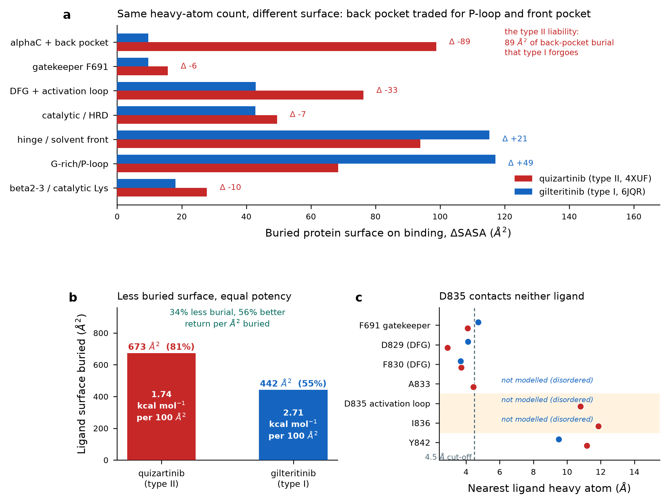
Figure. Interface decomposition of the FLT3 co-complexes, computed from the deposited coordinates by Shrake-Rupley solvent-accessible surface. (a) Buried protein surface by structural region, with the type I minus type II difference per region. (b) Total buried ligand surface and the apparent return per unit area. (c) Nearest ligand heavy atom to each resistance-relevant residue; residues 831-836 are not modelled in 6JQR.

Region | quizartinib dSASA (A2) | gilteritinib dSASA (A2) | Difference
alphaC + back pocket | 98.8 | 9.7 | -89.1
gatekeeper F691 | 15.7 | 9.7 | -6.0
DFG + activation loop | 76.3 | 42.9 | -33.4
catalytic / HRD | 49.5 | 42.8 | -6.7
hinge / solvent front | 93.9 | 115.3 | 21.4
G-rich/P-loop | 68.4 | 117.1 | 48.7
beta2-3 / catalytic Lys | 27.8 | 18.1 | -9.7

The trade is explicit. Quizartinib buries 98.8 A2 of alphaC and back-pocket surface; gilteritinib buries 9.7 A2 - a difference of 89 A2 that the type I chemotype forgoes entirely. It recovers surface elsewhere: 49 A2 more in the glycine-rich P-loop and 21 A2 more across the hinge and solvent front. The DFG and activation-loop region also contributes 33 A2 less, which is consistent with that segment being partly disordered in the type I complex (35.4).
35.3 The Cost of N_bp = 0
PDB | Ligand | Heavy atoms | Free SASA (A2) | Buried (A2) | Buried % | Buried/atom (A2) | Back-pocket (A2) | Back-pocket share
4XUF | P30 | 40 | 834.6 | 673.1 | 81% | 16.83 | 95.2 | 22.1%
6JQR | C6F | 40 | 802.0 | 441.5 | 55% | 11.04 | 0.0 | 0.0%
5X02 | F6M | 39 | 891.9 | 583.8 | 65% | 14.97 | 1.1 | 0.3%

PDB | Agent | pIC50 (ITD) | Buried (A2) | Apparent dG (kcal/mol) | kcal/mol per 100 A2
4XUF | quizartinib | 8.55 | 673.1 | -11.71 | 1.74
6JQR | gilteritinib | 8.74 | 441.5 | -11.97 | 2.71
5X02 | FF-10101 | - | 583.8 | - | -

THE ANSWER Choosing N_bp = 0 costs 231 A2 of buried ligand surface - 673 A2 down to 442 A2, a 34% reduction, and the buried fraction falls from 81% to 55%. It costs nothing in potency: the median ITD potency of gilteritinib in this dataset is slightly BETTER than quizartinib's (pIC50 8.74 against 8.55). The type I chemotype therefore extracts 2.71 kcal/mol per 100 A2 buried against 1.74 for the type II - about 56% more apparent binding energy per unit of interface. Burying the back pocket is an expensive way to buy affinity.

Design consequence: do NOT try to replace lost back-pocket burial with
added bulk. Recover affinity in the P-loop and hinge/solvent front,
where the observed return per unit area is higher.
Where to Spend Surface

This also reconciles the property data in Appendix B with the structural data. The type I agents in this set are markedly less lipophilic - mean ALogP 3.87 against 5.23 - and the interface decomposition shows why that is available to them: they do not need the large apolar extension that reaches the back pocket. Chemotype choice and developability point the same way, which is unusual and worth exploiting.
35.4 Why Activation-Loop Resistance Is Conformational, Not Contact Loss
The single most useful structural result here is a negative one. D835 - the residue whose substitution costs quizartinib 49-fold potency - makes no contact with quizartinib at all.
Residue | quizartinib 4XUF (A) | gilteritinib 6JQR (A) | FF-10101 5X02 (A)
F691 gatekeeper | 4.1 | 4.72 | 3.49
D829 (DFG) | 2.9 | 4.11 | 3.27
F830 (DFG) | 3.71 | 3.67 | 3.71
A833 | 4.43 | - | 5.86
D835 activation loop | 10.79 | - | 8.38
I836 | 11.86 | - | 11.23
Y842 | 11.18 | 9.51 | 10.51

Nearest approach of D835 to quizartinib is 10.79 A, and to FF-10101 8.38 A. In the gilteritinib complex the residue is not modelled at all. A substitution 10.8 A from the ligand cannot remove a binding interaction, so the 49-fold loss must act through the conformational state: type II binding requires the activation loop to adopt and hold the inactive arrangement, and activation-loop substitutions destabilise it. The mutation does not take away a contact; it takes away the conformation the contact set depends on.
Structure | Modelled span | Chain gaps | Activation-loop status
4XUF (quizartinib, type II) | 600-947 | 649-651, 708-782 | none - 825-850 fully modelled
6JQR (gilteritinib, type I) | 571-951 | 634-636, 649-650, 711-761, 763-780, 831-836 | 831-836 absent: includes D835 and I836
5X02 (FF-10101, covalent) | 573-947 | 712-781 | none - 825-850 fully modelled

THE CORROBORATING OBSERVATION Residues 831-836 - the segment containing D835 and I836, the two commonest activation-loop resistance positions - are absent from the gilteritinib model, while they are fully resolved in both the quizartinib and FF-10101 models. The type I complex does not require that segment to be ordered. That is exactly the asymmetry the fold-shift data show: an inhibitor indifferent to the conformation of a loop is indifferent to mutations in it. Stated carefully, absence of density reflects mobility or heterogeneity in that crystal form and is supporting evidence, not proof of a functional requirement.

35.5 A Correction to Section 30.1
THE GATEKEEPER CLAIM WAS CUT-OFF DEPENDENT Section 30.1 reports that gilteritinib does not contact F691. That is true at the 4.5 A heavy-atom cut-off used there, but the interface decomposition shows it is a threshold artefact: gilteritinib's nearest approach to F691 is 4.72 A and it buries 9.7 A2 of that residue, against 15.7 A2 for quizartinib. The correct statement is that gilteritinib engages the gatekeeper about 40% less extensively than quizartinib, not that it avoids it. This matters because it explains the residual 5.6-fold F691L fold-shift for gilteritinib in 30.3 - a compound with genuinely zero gatekeeper engagement should show none. Report burial, which is continuous, rather than a contact count, which is a step function at an arbitrary distance.

35.6 What to Compute Next
The decomposition above is geometric. Three calculations would convert it into the design-grade numbers a programme needs, in increasing order of cost: per-residue interaction energy decomposition with an explicit force field, to separate polar from apolar contributions that dSASA credits equally; alchemical free-energy perturbation for D835Y, D835H and F691L in both complexes, to predict fold-shift for a new chemotype before synthesis; and enhanced sampling of the activation loop in the apo and type I-bound states, to test the conformational argument in 35.4 directly rather than inferring it from missing density.
XXXVI. FORCE-FIELD DECOMPOSITION: WHAT THE SURFACE ANALYSIS COULD NOT SEE
Section XXXV measured buried surface, which credits polar and apolar contact equally and cannot say whether a given region delivers energy in proportion to its area. This section answers that with a force field. It also returns a clear negative result: the central hypothesis of 35.3 is wrong, and what replaces it is more useful.
36.1 Method, and What It Is Not
Ligands were rebuilt from the PDB chemical-component SMILES with crystal coordinates preserved by bond-order templating, then charged with AM1-BCC. Complexes were assembled with AMBER14SB for protein and GAFF2 for ligand in GBn2 implicit solvent, and relaxed under positional restraints on protein heavy atoms so that added hydrogens and completed side chains could settle without the fold moving.
Ligand | Agent | Heavy atoms | Formula built | Matches CCD | Charge method | Net charge (e)
P30 | quizartinib | 40 | C29H32N6O4S | True | AM1-BCC (AmberTools/sqm) | +0.000
C6F | gilteritinib | 40 | C29H44N8O3 | True | AM1-BCC (AmberTools/sqm) | -0.000
F6M | FF-10101 | 39 | C29H38N8O2 | True | AM1-BCC (AmberTools/sqm) | +0.000

PDB | Segments kept | Modelled spans | Side-chain atoms completed | Protein RMSD (A) | Ligand RMSD (A) | Nearest artificial terminus (A)
4XUF | 3 | 600-648, 652-707, 783-947 | 0 | 0.146 | 0.949 | 13.87
6JQR | 5 | 571-633, 637-648, 651-710, 762-762, 781-830, 837-951 | 69 | 0.149 | 0.327 | 9.44

THREE PREPARATION CHOICES, ALL DELIBERATE First, absent loops were never modelled - 6JQR's 831-836 gap is left empty, because inserting invented coordinates for D835 into an analysis about D835 would be circular. Second, each contiguous segment became its own chain so the force field assigns proper termini instead of leaving dangling backbone; the nearest artificial terminus is 13.87 A from the ligand in 4XUF and 9.44 A in 6JQR, so none touches the interface. Third, restrained minimisation moved protein heavy atoms by only 0.15 A RMSD in both complexes, so the structures being scored are still the deposited ones.

E_vdw = SUM 4 eps_ij [ (sig_ij/r)^12 - (sig_ij/r)^6 ]
E_coul = SUM C q_i q_j / (eps r_ij)
Per-Residue Interaction Energy

Reported at two dielectric bounds:
eps = 1 unscreened gas-phase Coulomb, an UPPER bound on the polar term
eps = 4r r in Angstrom; the conventional cheap screening model
Dielectric Bounds

A UNITS ERROR WORTH RECORDING The eps(r) = 4r model is defined with r in Angstrom. Coded with r in nanometres it yields eps < 1 at contact distance and AMPLIFIES the Coulomb term instead of screening it - the first run returned a 'screened' total of -64.5 kcal/mol against an unscreened -22.1, which is impossible. The diagnostic is simple and worth building into any such calculation: screening can only ever reduce the magnitude of a pair term, so if the screened total exceeds the unscreened one, the units are wrong. After correction, monotonicity holds for every one of the atom pairs checked.

WHAT THESE NUMBERS ARE NOT These are interaction energies, not binding free energies. Desolvation, configurational entropy and protein reorganisation are all absent, and the calculation is a single relaxed structure rather than an ensemble. They are therefore valid for comparing WHERE energy comes from within and between these two complexes, and invalid as predictions of affinity.

36.2 The Interface Is Almost Entirely Apolar
Agent | E_vdw | E_coul (eps=1) | E_coul (eps=4r) | Total (eps=4r) | Apolar fraction
quizartinib | -70.73 | -22.11 | -6.45 | -77.18 | 0.916
gilteritinib | -48.89 | -29.07 | -6.4 | -55.29 | 0.884

Van der Waals dominates both interfaces - 92% of the favourable energy for quizartinib and 88% for gilteritinib. The screened Coulomb terms are, strikingly, almost identical (-6.45 against -6.40 kcal/mol) despite very different chemotypes. So the surface analysis in XXXV was not misled by treating polar and apolar contact alike: at this interface there is very little polar contribution to mistreat. The corollary matters for design - a larger interface here is a larger APOLAR interface, and apolar burial carries a desolvation cost that scales with it.
Agent | 1st | 2nd | 3rd | 4th | 5th | 6th
quizartinib | ASP829 (-6.0) | LEU616 (-5.7) | GLU661 (-5.5) | CYS828 (-4.6) | LEU818 (-4.2) | PHE830 (-3.7)
gilteritinib | LEU616 (-8.6) | TYR693 (-4.9) | GLY697 (-4.1) | LEU818 (-3.9) | PHE830 (-3.7) | CYS694 (-3.3)

The top contributors reproduce the regional split from XXXV independently. Quizartinib's list is led by D829 and F830 of the DFG motif, the alphaC glutamate E661 and C828 - the back pocket and activation-segment machinery. Gilteritinib's is led by L616 in the P-loop and Y693/G697 at the hinge and solvent front. Two different chemotypes, two different halves of the site.
36.3 Energy Density Is Flat - the 35.3 Hypothesis Refuted
Section 35.3 inferred that gilteritinib's P-loop and hinge surface must be of higher energetic quality than quizartinib's back-pocket surface, since gilteritinib achieved equal potency from 34% less burial. The force field does not support that.
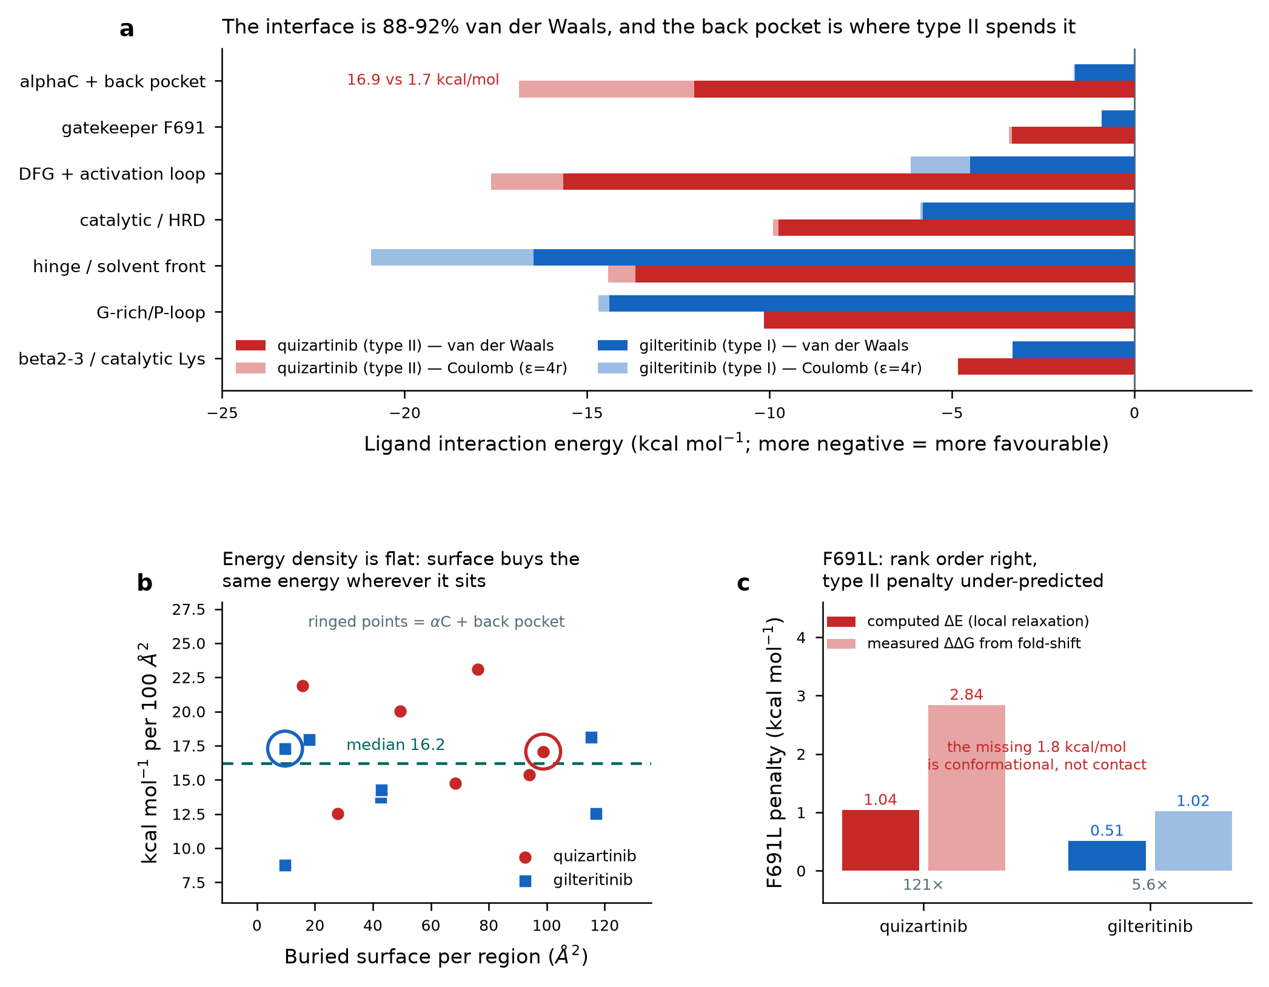
Figure. Force-field decomposition of the two FLT3 complexes. (a) Interaction energy by region, split into van der Waals and screened Coulomb. (b) Energy density against buried surface per region; the ringed points are the alphaC/back-pocket region for each complex. (c) Computed local F691L penalty against the penalty implied by the measured fold-shift.

Region | Agent | dSASA (A2) | E_vdw | E_coul | E_total | kcal/100 A2 | Apolar frac.
G-rich/P-loop | quizartinib | 68.4 | -10.16 | 0.07 | -10.09 | 14.75 | 0.993
beta2-3 / catalytic Lys | quizartinib | 27.8 | -4.83 | 1.35 | -3.48 | 12.54 | 0.782
alphaC + back pocket | quizartinib | 98.8 | -12.07 | -4.8 | -16.87 | 17.07 | 0.716
gatekeeper F691 | quizartinib | 15.7 | -3.35 | -0.09 | -3.44 | 21.91 | 0.974
hinge / solvent front | quizartinib | 93.9 | -13.67 | -0.75 | -14.43 | 15.36 | 0.948
catalytic / HRD | quizartinib | 49.5 | -9.76 | -0.15 | -9.91 | 20.02 | 0.985
DFG + activation loop | quizartinib | 76.3 | -15.65 | -1.97 | -17.63 | 23.1 | 0.888
G-rich/P-loop | gilteritinib | 117.1 | -14.39 | -0.31 | -14.7 | 12.55 | 0.979
beta2-3 / catalytic Lys | gilteritinib | 18.1 | -3.35 | 0.1 | -3.25 | 17.94 | 0.971
alphaC + back pocket | gilteritinib | 9.7 | -1.62 | -0.05 | -1.67 | 17.29 | 0.972
gatekeeper F691 | gilteritinib | 9.7 | -0.9 | 0.05 | -0.84 | 8.75 | 0.943
hinge / solvent front | gilteritinib | 115.3 | -16.47 | -4.44 | -20.91 | 18.14 | 0.788
catalytic / HRD | gilteritinib | 42.8 | -5.8 | -0.07 | -5.87 | 13.72 | 0.987
DFG + activation loop | gilteritinib | 42.9 | -4.51 | -1.61 | -6.13 | 14.27 | 0.737

THE RESULT Energy density is close to uniform - a median of 16.2 kcal/mol per 100 A2 across regions and across both drugs. The back pocket returns 17.07 for quizartinib and 17.29 for gilteritinib; the P-loop plus front returns 15.10 and 15.33. Buried surface buys essentially the same interaction energy wherever it sits, and the back pocket is not energetically inferior per unit area. The 56% efficiency advantage in 35.3 is therefore NOT explained by contact quality.

That leaves a sharper conclusion. Quizartinib extracts MORE total interaction energy than gilteritinib - -77.18 against -55.29 kcal/mol, a surplus of about 22 kcal/mol - while being no more potent. A surplus of favourable interaction energy that does not appear as affinity must be repaid in terms this calculation cannot see, and there are only two serious candidates: desolvation of a much larger apolar surface, and the free-energy cost of requiring the protein to occupy the DFG-out, activation-loop-ordered state that type II binding demands.
Both candidate costs scale with the SAME structural feature that Section XXX
identified as the type II resistance liability: dependence on an ordered
back pocket. The affinity penalty and the resistance liability are the
same bill, presented twice.
The Unifying Statement

REVISED DESIGN GUIDANCE Section 35.3 advised recovering lost back-pocket burial at the P-loop and front pocket because the return per unit area was better there. That reasoning was wrong - the return is the same. The advice survives for a different and stronger reason: surface at the P-loop and front does not commit the inhibitor to a particular activation-loop conformation, so it buys affinity without buying a resistance liability. Choose where to place surface by the conformational dependence it creates, not by its expected energy density.

36.4 F691L: Rank Order Right, Magnitude Under-Predicted
F691 is a genuine contact residue in both complexes, so unlike D835 it is legitimate to assess in the bound state. The phenyl ring was deleted to leucine, hydrogens rebuilt, and the site relaxed from five perturbed starting conformations with the rest of the structure restrained.
Agent | WT energy at 691 | dE at 691 | dE total | Spread (sd) | Measured fold-shift | Implied ddG (kcal/mol)
quizartinib | -3.44 | 1.59 | 1.04 | 0.05 | 121x | 2.84
gilteritinib | -0.84 | 0.16 | 0.51 | 0.05 | 5.6x | 1.02

The wild-type interaction at residue 691 is -3.44 kcal/mol for quizartinib against -0.84 for gilteritinib, a four-fold difference that tracks the 15.7 against 9.7 A2 of burial from XXXV. The mutation's computed penalty ranks the two agents correctly, and the conformer spread is negligible (0.05 kcal/mol across five starts), so the estimate is at least locally stable.
WHERE IT FAILS, AND WHY THAT IS INFORMATIVE Both computed penalties fall short of the measured ones. For gilteritinib the computed +0.51 kcal/mol is half of the +1.02 implied by its 5.6-fold shift (0.51 unaccounted for). For quizartinib the computed +1.04 recovers only 37% of the +2.84 implied by 121-fold - roughly 1.8 kcal/mol unaccounted for. The rank order is correct in both cases; the magnitudes are not, and the shortfall is about three and a half times larger for the type II agent. This is the same gap as in 36.3, from the other direction: F691L does not merely remove contacts, it destabilises the DFG-out back-pocket architecture, and a local relaxation of one structure cannot represent that. A method that scores contacts will under-predict resistance for both classes and most severely for type II inhibitors. Do not use a contact-based score to triage type II chemotypes against activation-segment mutations, and do not read the type I value as a quantitative prediction.

36.5 Specification for the Calculations That Need a GPU
No compute target was available for this work, and the machine has no GPU, so everything above is single-point and minimisation-scale. Two calculations would close the remaining gaps. They are specified here concretely enough to dispatch if a GPU host is added, rather than described in the abstract.
Calculation | Method and system | Cost estimate | The number it returns
F691L alchemical free energy - do this first | Relative binding FEP, Phe->Leu in the bound and apo legs, 12-16 lambda windows, 5 ns per window, Hamiltonian replica exchange. Solvated kinase domain, roughly 45,000 atoms, TIP3P, AMBER14SB with GAFF2 ligand. Both complexes. | About 10 h per leg per complex on one modern GPU; roughly one day for the full set. | ddG_bind for F691L, directly comparable to the +2.84 and +1.02 kcal/mol measured here. Confirms whether the 1.8 kcal/mol shortfall in 36.4 is recovered by proper sampling and solvation, or is genuinely conformational.
Conformational free energy of the activation segment | Well-tempered metadynamics or umbrella sampling along a DFG/activation-loop collective variable set (Phe830 displacement plus activation-loop RMSD to the DFG-out reference), on the APO kinase domain for wild type, D835Y and D835H. Multiple walkers. | About 1 microsecond aggregate per variant to converge the basin populations; several days per variant on one GPU, three variants. | The shift in free-energy difference between the DFG-out and DFG-in basins caused by each D835 substitution. This is the quantity that should predict the 49-fold type II fold-shift, and the one no bound-state calculation can return.
Optional: per-chemotype prospective screen | Once the F691L protocol above is validated against the two known agents, run the same FEP on candidate chemotypes before synthesis. | Roughly one GPU-day per candidate per mutation. | Predicted mutant fold-shift, which is exactly the quantity the stage-2 gate of the cascade in Section XXXIII turns on.

WHY THE ORDER MATTERS The F691L calculation comes first not because it is the more important question but because it is the one with a measured answer to validate against. A protocol that reproduces +2.84 and +1.02 for two known agents can be trusted on a new chemotype; the conformational calculation has no comparably direct experimental anchor, so it should be attempted only once the force field and sampling have been shown to work on the easier case.

XXXVII. PROSPECTIVE CANDIDATES AGAINST THE STRUCTURAL CRITERION
Sections XXX to XXXVI derived a design criterion from measured data - avoid back-pocket occupancy, recover affinity at the P-loop and hinge - and then stopped. This section closes that loop by generating molecules, predicting their poses, and scoring them with the same pipeline that was validated on two crystal structures. The honest summary is that the exercise worked, and that its most useful output is a correction to how the criterion must be applied.
37.1 The Design Envelope, Derived Rather Than Asserted
Acceptance windows come from the type I subset of the ten agents characterised in XXIX, not from generic Rule-of-Five limits. Midostaurin is excluded from the envelope and the exclusion is recorded: it is a staurosporine-derived multikinase agent whose ALogP of 5.91 and LLE of 2.05 sit in type II territory, it is the weakest type I by pIC50, and keeping it would erase the class separation the envelope depends on.
Parameter | Window low | Set by | Window high | Set by | Type I core mean | Type II mean
MW | 398.48 | sunitinib | 552.72 | gilteritinib | 458.56 | 507.72
ALogP | 2.7 | gilteritinib | 3.92 | crenolanib | 3.35 | 5.23
PSA | 77.23 | sunitinib | 121.11 | gilteritinib | 91.36 | 84.61
RTB | 1.0 | lestaurtinib | 9.0 | gilteritinib | 5.5 | 6.2
QED | 0.37 | lestaurtinib | 0.63 | sunitinib | 0.48 | 0.38
LE | 0.3 | gilteritinib | 0.39 | sunitinib | 0.36 | 0.31
LLE | 4.97 | crenolanib | 6.04 | gilteritinib | 5.33 | 2.5

TWO PROPERTIES SEPARATE THE CLASSES CLEANLY With midostaurin set aside, ALogP splits the two classes with no overlap at all - every type I core agent sits between 2.70 and 3.92, every type II between 4.46 and 5.86 - and LLE separates them by a 2.28-unit margin (4.97-6.04 against 2.15-2.69). LLE is therefore the single most discriminating property metric in this series. The catch is that LLE and LE both require a measured potency, so neither can be applied prospectively to a molecule that has never been assayed. They are post-hoc checks, and the prospective gates reduce to ALogP, MW, PSA, rotatable bonds, Ro5 count and a similarity corridor.

37.2 Validating the Scoring Pipeline Before Trusting It
The criterion was derived from crystal poses. Whether predicted poses can support it is a separate question, and it was settled first, on the two drugs whose answers are already known, so that a failure would stop the campaign rather than be discovered afterwards. Each drug was re-docked into its own receptor from a conformer built from SMILES alone, carrying no crystal geometry.
Agent | Receptor | Mode | Poses | RMSD rank-1 | RMSD best | n_bp crystal | n_bp docked | bp dSASA crystal | bp dSASA docked | Buried crystal | Buried docked | Confidence
gilteritinib | 6JQR | self | 10 | 3.06 | 2.3 | 0.0 | 0 | 0.0 | 0.0 | 456.9 | 434.7 | -0.309
quizartinib | 4XUF | self | 10 | 1.28 | 1.12 | 6.0 | 5 | 74.6 | 70.8 | 696.6 | 689.0 | -0.228
quizartinib | 6JQR | cross | 10 | - | - | - | 4 | - | 11.4 | - | 654.9 | -0.956

Back-pocket burial is recovered in both directions: gilteritinib gives 0.0 square angstroms across all ten poses, identical to its crystal value of 0.0, and quizartinib 60.6 to 80.9 against a crystal 74.6. Total ligand burial lands within 5% and 1% of crystal respectively. Pose accuracy is asymmetric, and the weaker case is the production one - quizartinib's rank-1 pose is 1.28 angstroms from crystal, inside the conventional 2.0 angstrom success bar, while gilteritinib's is 3.06 with a best-of-ten of 2.30. The criterion nevertheless survives that error, which is the result that licenses the rest of this section: a 3 angstrom pose still correctly reports zero back-pocket burial.
THE CONTROL CHANGED THE METRIC Cross-docking quizartinib into the type I receptor moved n_bp only from 5/6 to 4/5 while back-pocket burial collapsed from 70.8 to 11.4 square angstroms - a 6.2-fold separation invisible to the contact count. This confirms from an independent direction the conclusion of 36.4: report burial, which is continuous, rather than contact counts, which are a step function at an arbitrary distance. The ranking below therefore uses burial. DiffDock's own confidence also tracked the mismatch, -0.23 in the native receptor against -0.96 cross-docked, making it usable as a sanity filter.

37.3 The Criterion Cannot Be Applied in the Receptor It Came From
Scoring the generated set in 6JQR produced a result that looked like success and was not: three quarters of all candidate poses buried exactly zero back-pocket surface. The control explains why. 6JQR's conformation denies back-pocket access to everything, including quizartinib, which manages only 11.4 square angstroms there. In that receptor, N_bp = 0 is a property of the protein, not of the ligand, and the criterion has no discriminating power at all.
The discriminating experiment is the opposite one:
dock into 4XUF, where the back pocket is OPEN, and ask whether
the candidate still refuses to bury there.
Open-Pocket Test

All 76 candidates were therefore docked into 4XUF as well. Fourteen of them - 18% - bury more than half of quizartinib's back-pocket surface once the pocket is available, despite every one of them reading N_bp = 0 in 6JQR. They are latent type II scaffolds, and a criterion applied only in the type I receptor would have passed them. Open-pocket burial correlates with molecular size at r = 0.475, so the effect is partly but not wholly a size artefact.
A GENERAL LESSON FOR CONFORMATION-SELECTIVE DESIGN A negative structural criterion - the absence of an interaction - cannot be tested in a receptor conformation that forbids that interaction for every ligand. The test has to be run where the interaction is possible. This generalises well beyond FLT3: any programme selecting for conformational selectivity should screen in the conformation it wants to AVOID, not only in the one it wants to occupy.

37.4 The Funnel
Stage | Surviving | Detail
Raw molecules generated | 270 | MolMIM 150 across 5 similarity levels; GenMol 120 across 4 settings
Unique canonical structures | 211 | 59 duplicate structures removed
Through the property envelope | 76 | 64 too dissimilar to the chemotype; 33 near-duplicate of the seed; 16 MW above 580; 15 ALogP above 4.0 (type II territory)
Docked into 6JQR | 76 | 760 poses, no endpoint failures
Genuinely type I in the OPEN pocket | 53 | back-pocket burial <= 7.1 A2 in 4XUF
Recover gilteritinib's front-pocket burial | 25 | >= 201.8 A2
Pass all three structural gates | 11 | plus DiffDock confidence >= -1.0
Clash-free at 2.00 A | 10 | 1 excluded: a 1.10 A contact, +413.77 kcal/mol

TWO FILTERS THAT HAD TO BE DEMOTED OR RECALIBRATED The PAINS substructure filter flags gilteritinib itself, so it was recorded rather than applied as a gate - the same principle the Volume I audit applied to numeric thresholds: a filter that rejects the approved reference compound cannot arbitrate the series. Separately, a steric-clash screen set at 2.60 angstroms rejected the crystal quizartinib pose, whose own closest heavy-atom approach is 2.11 angstroms; it was reset to 2.00 angstroms, below every reference pose.

One further note on the generators. All 76 survivors came from MolMIM; GenMol contributed none, because its conservative single-group edits land at Tanimoto 0.80 to 1.00 against the seed and are eliminated by the novelty ceiling. MolMIM's QED objective pulls the other way and shrinks molecules - median 29 heavy atoms against 40 for both reference drugs - so 38 candidates fall below the type I core molecular-weight floor. Those were kept deliberately, to be adjudicated by burial rather than by an arbitrary size gate.
37.5 The Surviving Candidates
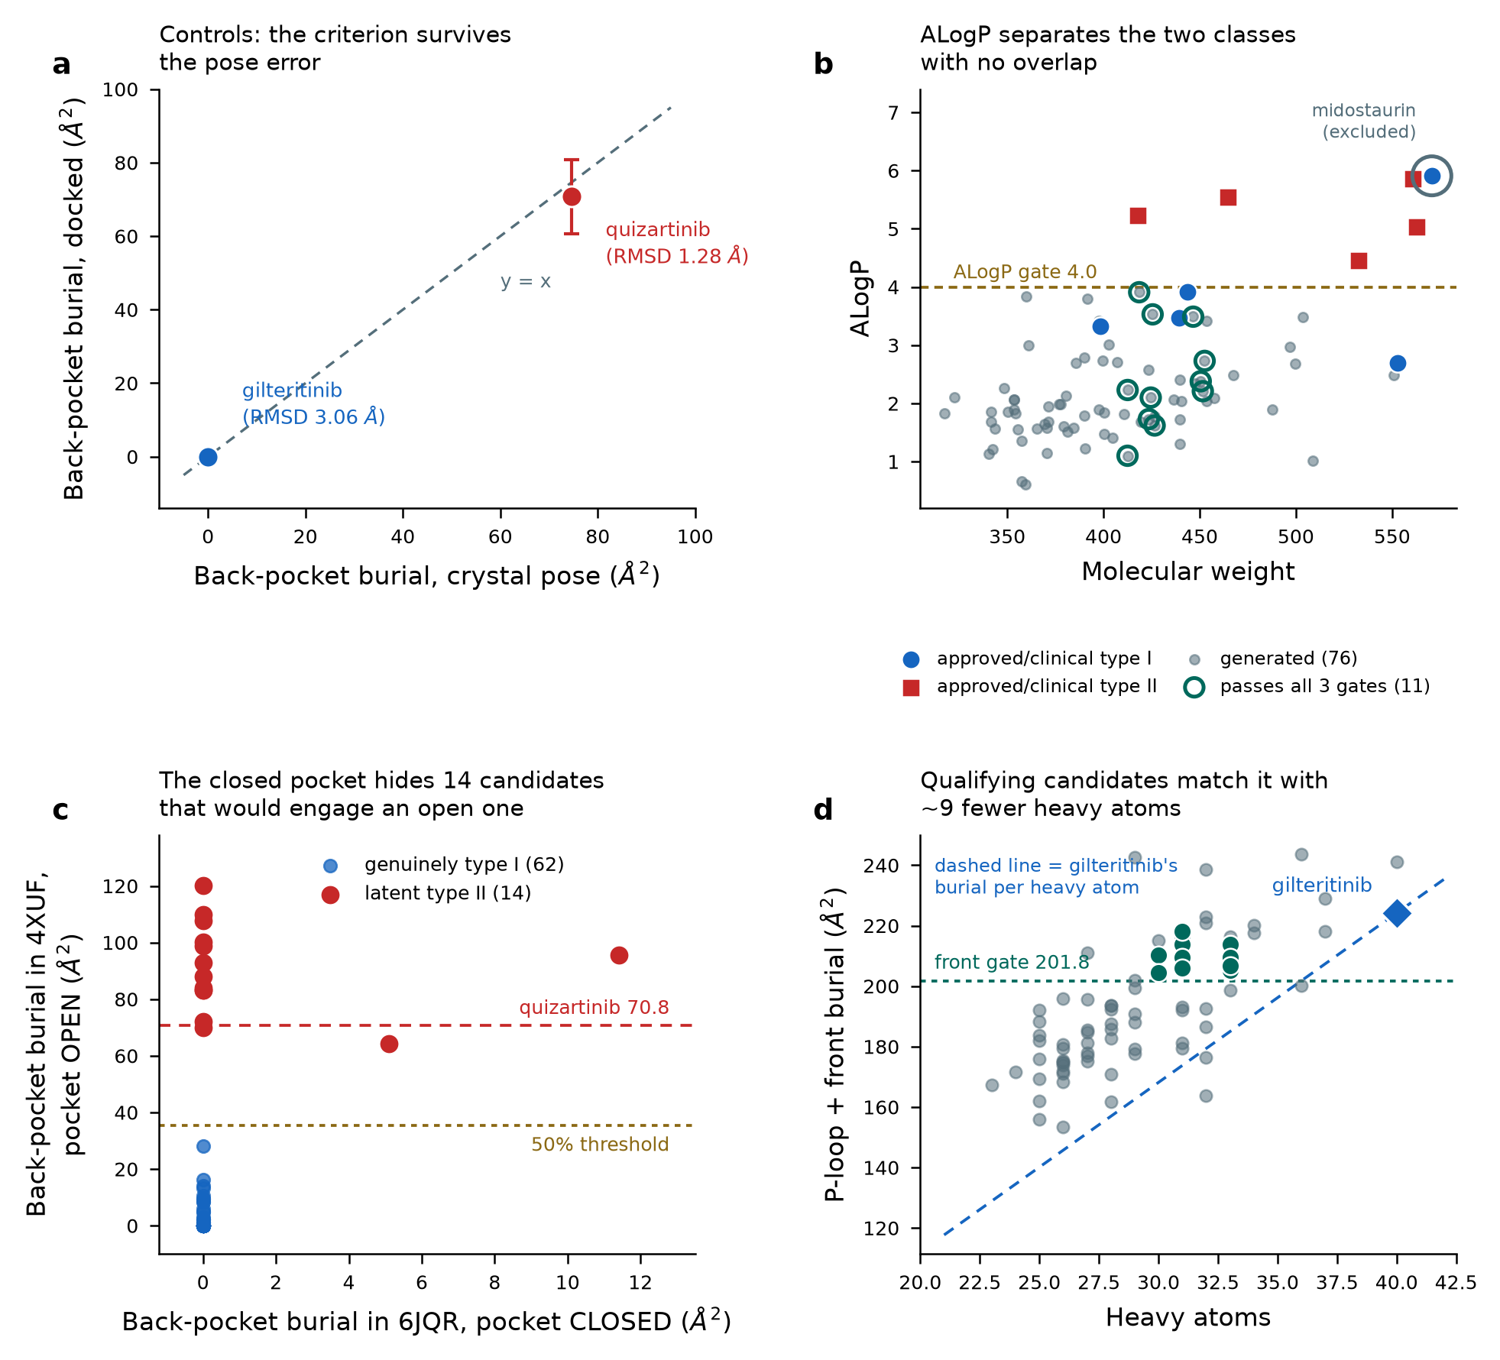
Figure. Prospective candidate generation against the structural criterion. (a) Control validation: docked against crystal back-pocket burial for both reference drugs, with the spread over ten poses and rank-1 RMSD. (b) Property space: generated molecules against the ten characterised agents, with the ALogP gate and the excluded outlier marked. (c) The open-pocket test - back-pocket burial in the closed receptor against the open one, exposing fourteen latent type II scaffolds invisible in the closed conformation. (d) Front-pocket burial against molecular size, with gilteritinib's burial per heavy atom as the reference slope.

ID | MW | ALogP | QED | Tanimoto to gilteritinib | Heavy atoms | Closest contact (A) | Back-pocket burial, OPEN pocket (A2) | Front burial (A2) | Confidence
C069 | 424.55 | 2.1 | 0.621 | 0.344 | 31 | 2.72 | 0.0 | 216.2 | 0.279
C050 | 425.53 | 3.53 | 0.704 | 0.286 | 31 | 2.46 | 0.0 | 213.9 | -0.737
C034 | 426.57 | 1.62 | 0.741 | 0.345 | 31 | 2.6 | 2.1 | 218.1 | 0.003
C019 | 412.54 | 2.23 | 0.781 | 0.326 | 30 | 2.74 | 0.0 | 210.4 | -0.239
C022 | 423.57 | 1.73 | 0.775 | 0.286 | 31 | 2.15 | 0.0 | 209.6 | -0.135
C032 | 451.62 | 2.21 | 0.748 | 0.3 | 33 | 2.14 | 0.0 | 209.5 | -0.797
C065 | 418.55 | 3.91 | 0.65 | 0.292 | 31 | 3.0 | 0.0 | 205.9 | 0.173
C035 | 412.49 | 1.1 | 0.741 | 0.315 | 30 | 2.45 | 0.0 | 204.5 | -0.274
C055 | 450.54 | 2.38 | 0.689 | 0.287 | 33 | 2.59 | 1.1 | 205.1 | -0.572
C060 | 452.56 | 2.73 | 0.666 | 0.299 | 33 | 2.79 | 2.1 | 206.7 | 0.135

Ten candidates pass every gate. They sit at 30 to 33 heavy atoms against 40 for both reference drugs, and reach 92 to 97% of docked gilteritinib's front-pocket burial - roughly 24% more front-pocket burial per heavy atom.
37.6 Force-Field Confirmation on the Leaders
ID | Heavy atoms | E_vdw | E_coul (eps=4r) | E_total | E back pocket | E front | kcal/mol per heavy atom
C069 | 31 | -44.26 | -3.19 | -47.45 | -1.45 | -33.98 | -1.531
C050 | 31 | -44.37 | -1.83 | -46.19 | -1.35 | -29.77 | -1.49
C034 | 31 | -46.29 | -5.21 | -51.49 | -1.63 | -35.2 | -1.661
C019 | 30 | -47.56 | -4.96 | -52.52 | -2.18 | -34.15 | -1.751
C022 | 31 | -44.83 | -3.83 | -48.66 | -1.37 | -33.11 | -1.57
gilteritinib (Sec. XXXVI) | 40 | -48.89 | -6.4 | -55.29 | -1.67 | -35.61 | -1.382
quizartinib (Sec. XXXVI) | 40 | -70.73 | -6.45 | -77.18 | -16.87 | -24.52 | -1.93

THE DESIGN RULE, REALISED The leading candidate returns -1.751 kcal/mol per heavy atom against gilteritinib's -1.382 and quizartinib's -1.930 - 27% better than the type I reference and within 9% of the type II reference, while holding back-pocket energy at -2.18 against quizartinib's -16.87. Front-pocket energy of -29.8 to -35.2 matches gilteritinib's -35.61 and exceeds quizartinib's -24.52. This is precisely the trade the revised guidance in 36.3 specified: comparable engagement, placed where it creates no conformational dependence.

AND A POSE THE STRUCTURAL GATES COULD NOT SEE One of the six leaders failed the force-field step with a total of +413.77 kcal/mol, traced to a 1.35 angstrom heavy-atom contact with Tyr693. That pose had passed all three structural gates, because burial metrics are blind to steric overlap - two atoms occupying the same space bury each other's surface perfectly well. A clash screen was added as a consequence. Of the six candidates where both were computed, the cheap geometric screen and the expensive energy calculation agree completely.

37.7 What These Molecules Are, and What They Are Not
Stated plainly, because the preceding volumes stated that no chemical matter was proposed and that is no longer true:
Limit | Consequence
Generation was not activity-guided | MolMIM optimised a generic drug-likeness score, not FLT3 inhibition. These are chemotype-space hypotheses that satisfy a structural criterion; nothing here predicts that any of them binds FLT3.
Poses are predictions, not structures | The production case is the weaker control - type I pose recovery was 2.3 to 3.1 angstroms RMSD. Every burial number and every interaction energy inherits that uncertainty. The criterion was shown to survive it; individual values were not.
No affinity was computed | DiffDock scores geometry. The ranking is structural, not energetic, and the interaction energies in 37.6 are single-structure values with no desolvation or entropy - valid for comparison within this set, invalid as affinity predictions.
No synthesisability assessment | Nothing in this pipeline asks whether a molecule can be made. These are starting points for a medicinal chemist to accept or reject, not a synthesis list.
No mutant testing | The whole point of a type I scaffold is retained potency against D835 and F691L variants, and that requires the free-energy calculations specified in 36.5. Until those run, conformational selectivity is inferred from burial geometry, not demonstrated.

RESEARCH USE ONLY The structures in this section are computational hypotheses generated and scored in silico. They have not been synthesised, assayed, or assessed for selectivity, ADMET or safety, and no claim is made about their activity, developability or utility. Nothing here is a treatment, a clinical candidate, or clinical guidance of any kind.

APPENDIX A. FLT3 STRUCTURES USED
All FLT3 entries in the PDB carrying UniProt accession P36888, retrieved programmatically. The three inhibitor co-complexes marked below carry the contact analysis in Section 30.1.
PDB | Year | Res. (A) | Principal ligand | Title
1RJB | 2004 | 2.1 | (apo) | Crystal Structure of FLT3
3QS7 | 2011 | 4.3 | NAG:2-acetamido-2-deoxy-be | Crystal structure of a human Flt3 ligand-receptor ternary
3QS9 | 2011 | 7.8 | (apo) | Crystal structure of a human Flt3 ligand-receptor ternary
4RT7 | 2015 | 3.1 | P30:1-(5-tert-butyl-1,2-ox | Crystal Structure of FLT3 with a small molecule inhibitor
4XUF | 2015 | 3.2 | P30:1-(5-tert-butyl-1,2-ox | Crystal structure of the FLT3 kinase domain bound to the i
5X02 | 2018 | 2.401 | F6M:N-[(2S)-1-[5-[2-[(4-cy | Crystal structure of the FLT3 kinase domain bound to the i
6IL3 | 2018 | 2.5 | A9R:7-methoxy-6-(1-methyl- | Crystal structure of the FLT3 kinase bound to a small mole
6JQR | 2019 | 2.2 | C6F:6-ethyl-3-[[3-methoxy- | Crystal structure of FLT3 in complex with gilteritinib
7QDP | 2022 | 3.691 | NAG:2-acetamido-2-deoxy-be | Crystal structure of FLT3 T343I in complex with the canoni
7ZV9 | 2023 | 4.507 | NAG:2-acetamido-2-deoxy-be | Crystal structure of FLT3 in complex with a monomeric FLT3
8XB1 | 2024 | 2.85 | ZX3:3^3-ethyl-5^4-morpholi | Crystal structure of FLT3 in complex with a Pyrazinamide M

APPENDIX B. CALCULATED PROPERTIES OF THE PRECEDENTED AGENTS
Computed descriptors for the ten agents retrieved, with ligand efficiency and lipophilic ligand efficiency derived against the FLT3-ITD potency in Section 30.2. The property split between the classes is the developability argument in Section 34.1: mean ALogP 3.87 for type I against 5.23 for type II.
Agent | Class | MW | ALogP | PSA | RTB | QED | Ro5 | LE | LLE
crenolanib | I | 443.6 | 3.92 | 78.43 | 5 | 0.5 | 0 | 0.369 | 4.97
gilteritinib | I | 552.7 | 2.7 | 121.11 | 9 | 0.43 | 1 | 0.3 | 6.04
lestaurtinib | I | 439.5 | 3.47 | 88.65 | 1 | 0.37 | 0 | 0.366 | 5.35
midostaurin | I | 570.6 | 5.91 | 77.73 | 3 | 0.29 | 2 | 0.254 | 2.05
sunitinib | I | 398.5 | 3.33 | 77.23 | 7 | 0.63 | 0 | 0.392 | 4.97
pexidartinib | II | 417.8 | 5.23 | 66.49 | 5 | 0.47 | 1 | 0.366 | 2.51
ponatinib | II | 532.6 | 4.46 | 65.77 | 4 | 0.39 | 1 | - | -
quizartinib | II | 560.7 | 5.86 | 106.16 | 7 | 0.26 | 2 | 0.293 | 2.69
sorafenib | II | 464.8 | 5.55 | 92.35 | 5 | 0.46 | 1 | 0.33 | 2.15
tandutinib | II | 562.7 | 5.03 | 92.29 | 10 | 0.34 | 2 | 0.257 | 2.65

APPENDIX C. VERIFIED PRIMARY REFERENCES
Every reference below was resolved through CrossRef and PubMed and then reverse-validated: the identifier was re-resolved and the returned title checked against the expected title. None is quoted from memory.
TWO THINGS THE VALIDATION CAUGHT The registration-trial citation for gilteritinib first resolved to an erratum notice carrying the parent article's title and a single-page range, and the BeatAML 2018 citation first resolved to a trade-press news item. Both were rejected on reverse lookup and re-resolved to the primary articles. Errata inherit the original title, so a title-similarity check alone does not catch them - the page range and the DOI pattern do.

Key | Citation | How it was verified
nakao_itd | Nakao M et al. Leukemia 1996;10:1911-8. doi:PMID:8946930 | pubmed PMID lookup, title confirmed (no DOI registered)
ratify | Stone R et al. New England Journal of Medicine 2017;377:454-464. doi:10.1056/nejmoa1614359 | doi-reverse-lookup
admiral | Perl A et al. New England Journal of Medicine 2019;381:1728-1740. doi:10.1056/nejmoa1902688 | doi-reverse-lookup (candidate DOI confirmed)
quantum_first | Erba H et al. The Lancet 2023;401:1571-1583. doi:10.1016/s0140-6736(23)00464-6 | doi-reverse-lookup
smith_ac220 | Smith C et al. Nature 2012;485:260-263. doi:10.1038/nature11016 | doi-reverse-lookup
smith_al_res | Smith C et al. Blood 2013;121:3165-3171. doi:10.1182/blood-2012-07-442871 | doi-reverse-lookup
zarrinkar | Zarrinkar P et al. Blood 2009;114:2984-2992. doi:10.1182/blood-2009-05-222034 | doi-reverse-lookup
zorn_4xuf | Zorn J et al. Worldwide Protein Data Bank 2015. doi:10.2210/pdb4xuf/pdb | doi-reverse-lookup [PDB structure deposition, not a journal
ff10101 | Yamaura T et al. Blood 2018;131:426-438. doi:10.1182/blood-2017-05-786657 | doi-reverse-lookup (candidate DOI confirmed)
levis_pia | Levis M et al. Blood 2006;108:3477-3483. doi:10.1182/blood-2006-04-015743 | doi-reverse-lookup
eln2022 | Döhner H et al. Blood 2022;140:1345-1377. doi:10.1182/blood.2022016867 | doi-reverse-lookup
beataml2018 | Tyner J et al. Nature 2018;562:526-531. doi:10.1038/s41586-018-0623-z | doi-reverse-lookup (candidate DOI confirmed)
beataml2022 | Bottomly D et al. Cancer Cell 2022;40:850-864.e9. doi:10.1016/j.ccell.2022.07.002 | doi-reverse-lookup (candidate DOI confirmed)
gilteritinib_pc | Mori M et al. Investigational New Drugs 2017;35:556-565. doi:10.1007/s10637-017-0470-z | doi-reverse-lookup
crenolanib | Smith C et al. Proceedings of the National Academy of Sciences 2014;111:5319-5324. doi:10.1073/pnas.1320661111 | doi-reverse-lookup
kiyoi_ar | Kiyoi H et al. Blood 1999;93:3074-80. doi:PMID:10216104 | pubmed-title (no DOI registered)

COMPANION DOCUMENTS
Document | What it carries
Volume I, Corrected Edition | Sections I-IX: general pharmaceutical formulae with all audit corrections applied inline.
Volume II | Sections X-XIX: efficiency metrics, binding kinetics, IVIVE, biologics and ADCs, synergy, radiobiology, clinical translation, process science, assay statistics.
Volume III | Sections XX-XXVIII: oncology-exclusive models - myelosuppression, TGI-survival linkage, clonal evolution, tumour transport, cell-cycle scheduling, MRD, trial design, immune dynamics, cumulative toxicity.
Volume IV (this document) | Sections XXIX-XXXIV: the FLT3-ITD worked dossier.
Combined Front Matter | Unified contents, notation conventions and symbol glossary for Volumes I-IV.

IMPORTANT This volume is a design-criteria and programme-architecture document for research use. It proposes no novel chemical matter and recommends no specific compound. Numeric thresholds are working criteria for triage, not regulatory requirements, and potency values are medians over heterogeneous public assay conditions. Statements about approved agents describe published class behaviour and are not treatment guidance: dose selection, dose modification, supportive care, toxicity management and the interpretation of any biomarker for an individual patient are decisions for a qualified healthcare professional with access to the full clinical context. Drug development requires experimental validation, GLP/GMP compliance, IND filing and regulatory approval before administration to human subjects.

Oncology Drug Design Formulae Compendium · Volume IV: FLT3-ITD Target Dossier · Companion to Volumes I-III · For Research & Educational Use Only

